SATVA AYUR HEALTH CENTRE
Life through Ayurveda...

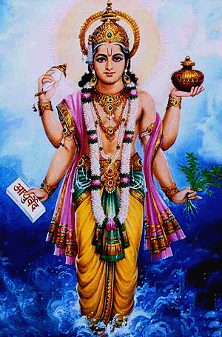

Welcome to the nature’s cradle

Ayurveda, for a healthy you, today and tomorrow
Ayurveda meaning ‘The science of life’ is a way of living, which aims towards “swasthya rakshanam (maintaining the health of the healthy) and “Athurasya Roganuth” (healing the ailments). India’s own contribution to the world, the healing methods of Ayurveda, is an over whelming experience.

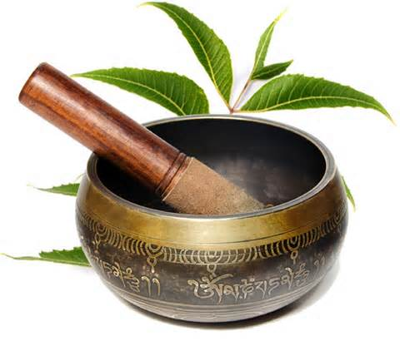

Indulge yourselves in cradle of Ayurveda, soothing your body, calming your mind and uplifting your spirits! Satva Ayur Health Centre has a team of well qualified doctors and therapists that sets the perfect ambience for your Healing and Wellness. With Satva Ayur Health Centre, life is meant to be lived for a Hundred Healthy Years!

Satva highlights

- DOCTOR CONSULTATION
- AYURVEDIC THERAPIES
- AYURVEDIC MEDICINE COUNTER
- SWARNA PRASHANA FOR CHILDREN
- AUTHORISED VAIDYARATNAM MEDICINE DEALER

TIMINGS

CONSULTATION
Monday to Saturday – 9:30am to 1:00pm
5:00pm to 8:00pm
TREATMENTS
7:00am to 8:00pm

AYURVEDIC THERAPIES
Abhyangam and Swedana

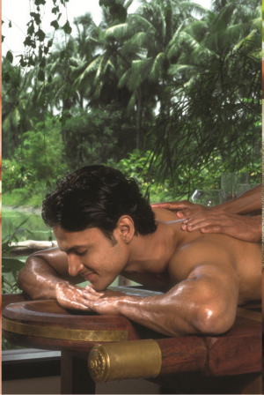
Abhyanga
The basic Satvic massage in Ayurveda with individual specific oils. Abhyanga stimulates circulation, mobilises nutrition and expels toxins, thereby tones and relaxes the muscles and strengthens the body.
45 min INR 1000
Vishesha abhyanga
Full body synchronised massage with specific strokes with medicated oil done by 4 hands which penetrates your deep tissues and boost up the immunity.
45 Min INR 1200
Rejuvenation massage
A 7 steps Rejuvenation massage with medicated oil to relax the muscles and strengthen the body.

60min INR 1500
Mardhana
Deep tissue massage with hard strokes to relax tiered muscles helps in deeper relaxation for who have consistent pain
45 Min INR 1200

Samvahana
Special feather touch gentle strokes to relax your sensitive skin with rare and exquisite essential oils extracted out of herbs (individual specific) good for circulation
45Min INR1100
Kaya seka
Pizhichil as it is commonly known is a procedure of pouring of warm medicated oils/ decoctions which relaxes and strengthens the whole body. Recuperative in vascular disorders, neuritis, musculo-skeletal disorders.
45Min INR2000
Sarwanga Udwarthana
A cleansing medicated powder massage to the largest organ in the body, the skin. It improves circulation, complexion, compactness of the body and effective in obesity.
45Min INR1200
Baala abyanga
Rejuvenating massage to children for strengthening of the tissues, with medicated oils.
30Min INR600
Spinal massage
Special massage for spine and back muscles, which relives pain and stiffness.
30min INR500
Sthanika abhyanga
Area specific massage
20Min INR400
Sthanika udwarthana
Area specific powder massage
30MIN INR500
Garbhini and Soothika abhyanga
Prenatal and postnatal massages 30MIN INR1000
Bhashpa sweda
Herbal steam bath, in steam chamber which helps the oils to penetrate deep inside and gives better result.
Sarvanga- 15 Min INR100
Sthanika -15Min INR50
Parisheka sweda
Herbal steam bath with pouring of warm decoctions.
Sarvanga -30Min INR500
Sthanika -15Min INR200
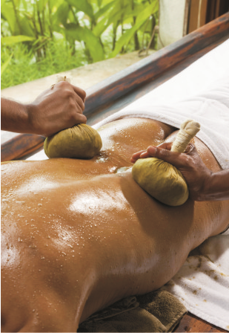
Patrapinda sweda

Ayurveda massage and fomentation techniques with herb bundles that relieve pain and soothe the tissue.

Sarvanga -30Min INR500 Sthanika -15Min INR200
Churna pinda sweda
Fomentation with medicated powder bundles, very beneficial in Arthritis joint stiffness etc.
Sarvanga -30 Min INR500
Sthanika -15Min INR200
Shasthtika shali pinda sweda
A nourishing treat to your body, NjavaraKizhi as it is known, the fomentation with medicated milk-cooked rice bundles after a massage, increases bulk and strength of muscles, rejuvenates the tissues work wonder in Musculo-skeletal disorders, Bronchial disorders, delayed milestones in kids, geriatric care etc.
Sarvanga -30Min INR600
Sthanika -20Min INR300
Valooka sweda
Fomentation technique to relax and distress deeper tissues and counter stiffness, pain and discomfort. This is a highly recommended therapy for arthritis and allied condition of muscles, bones and joints like fatigued legs, stressed back and tired shoulders
Sarvanga -40Min INR600
Sthanika -20Min INR300
NOTE:
- All swedana procedures work the best when done in an oiled body that allows good absorption of the medicines.
- The duration, selection of therapies as well as medicines, can alter according to the consultant opinion with respect to the Health condition, season etc.
- All Abyangam & Bhaspa sweda procedures will be followed by a body scrub.

Shiropakrama- Treatments for the Head and scalp
Shirodhara
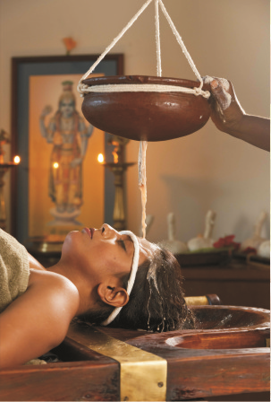
Taila dhara
Dhara the continuous flow of medicated oil over the fore head known as the “The third eye opener” dhara with oil strengthens the hair roots, relieves head ache and is deeply relaxing, effective in Anxiety disorders, Insomnia etc
60Min 1200INR

Ksheeradhara
The dhara procedure with medicated milk, this one is good remedy for disturbed sleep, anxiety and stress.
60Min 1000INR

Takra dhara
The continuous stream of medicated buttermilk over the fore head. It is de-stressing relaxing and refreshing. Effective in Diabetes and its complications, Vertigo etc.
60Min 1000INR
Sheetha sudha
A unique combination of medicated liquids poured in a Dhara over the forehead to cool the body, relax and rejuvenate. It relieves stress head ache, calms mind, relives anxiety and stress, induce sleep, effective in Hypertension.
45Min 800INR
Shiro abhyanga
The relaxing head massage with medicated oils that protects the sense organs, prevents hair fall, premature greying, and cools the head.
20Min 300INR
Shiro basti
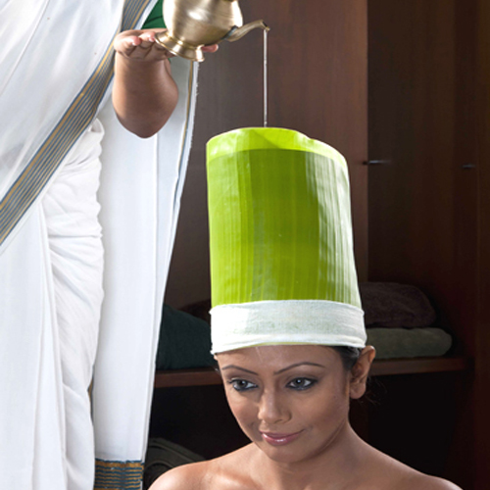
The procedure where-in warm medicated oils are retained in the head, tied up in a leather cap. Very effective in Neurological disorders, Parkinsonism, Insomnia etc.
60Min 800INR

Kesha kaanti
A therapeutic procedure which combines the goodness of a great oil massage & application of a herbal hair pack. This cooling therapy is recommended for maintenance of healthy hair, also attends to disorder like dandruff, hair fall etc.
45Min 600INR

INDRIYA PARICHARYA – Care of sense organs

Akshi tarpana
An external rejuvenating procedure which does wonders for the eyes, sooth, nourishes and relieves of eye strain, watering of eyes.
30Min 600INR
Akshi seka
A dhara for the eyes, it is the pouring of a continuous stream of medicated milk over the eyes. Relieves eye strain, watering of eyes & has cooling effect.
30Min 400INR
Karna poorana
An external rejuvenating procedure which strengthens ears and helpful in ear problems.
30Min 350INR

NOTE: The duration, selection of therapies as well as medicines, can alter according to the consultant opinion with respect to the Health condition.

SANDHI PARICHARYA – joints and spinal care
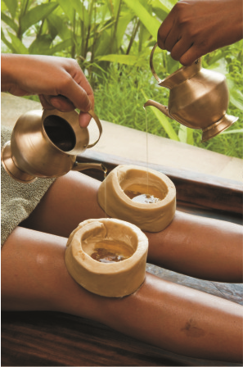
Janubasti
An external palliative and rejuvenating treatment to the knee joints, it reduces pain, weakness of the knee joint, strengthens and lubricate joint spaces and ligaments, helpful in degenerative arthritis etc.
60Min INR500
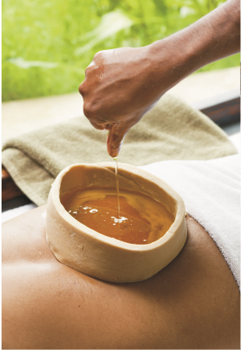

Kati basti
An external palliative and rejuvenating treatment to the low back, it strengthens the low back muscles, relieves strain and pain due to improper posture, spondylytic conditions, arthritis etc.
60Min INR600

Greeva basti
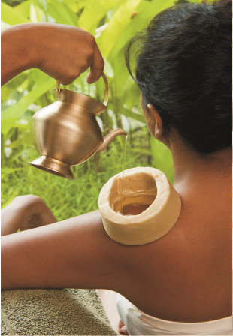
An external palliative and rejuvenating treatment to the nape of the neck, it relieves pain and strain in the neck, shoulder, lubricates and strengthens the cervical region.
60Min INR500

Alankara- beauty treatments

Lotus feet
Now you can get lotus feet too, with our foot care procedure, relieving them of stress strain and cracks, achieving great benefits.
60Min INR600
Navaneetha
Body massage with herbal creams which gives soft and supple skin like navaneeta (pure cream).
60Min INR1500
Mukha lepa (ayur facial)
Endowed with anti-aging properties, this one is highly recommended for mature skin. Bring back the lost glow and lustre to your skin with our special face skin care regime.
60Min INR700

- SHUDDI: Ayurvedic facial done with NEEM products which helps to cleanse the oily skin and get rid of ACNES.
- VARNA: Ayurvedic facial done with traditional Ayurvedic medicines like KUMKUMADI TAILA to give good COMPLEXION to the face.
- KAANTI: Ayurvedic facial done with milk and rice (NAVARA) which gives LUSTRE to the face.
- BALA: Ayuvedic facial done with DRY FRUITS preparations which TONE up the skin

Pancha Karma
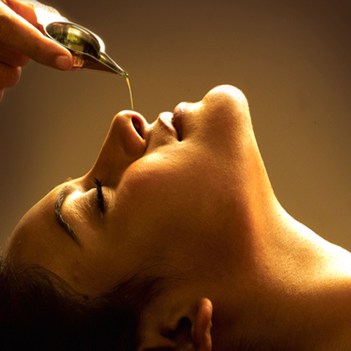

A penta-bio purification therapy, with preventive, curative, restorative, anti-aging and healing properties in many multi-channelized ailments.

Vamana karma- therapeutic emesis.
10- 12 days INR 7000
Virechana- therapeutic purgation.
10-14 days INR8000
Basti - medicated enema.
8/16/30Days INR 600/day
Nasya-
7days INR 6000
Raktamokshana- bloodletting.
INR 600/LEECH

Ayur-Satva
Satva signature therapies
AYURVEDAMRUTHA
- sarwanga Abhyanga and swedana
- shirodhara
2hrs INR 2000
AYUR RAKSHA
- sarwanga abhyanga and swedana
- shirodhara
- ayur facial
2 1/2 hrs INR 2600

AYUR LAGHAVA
- sarwanga udwarthana
- sarwanga abhyanga and swedana
2hrs INR2000
AYURPUSTI
- navara facial
- fullbody navara massage
2hrs INR 2000
KAYA KALPA
- sarwanga udwarthana
- sarwanga abhyanga and swedana
- shirodhara
3hrs INR 3100

TARUNYA
- Sarwanga abhyanga and swedana
- Lotus feet
- Ayur facial
- Kesha kaanthi
3hrs INR3000

Weight management programs
Type 1: virechana - 11days- Rs. 8000
Type 2: 6 udwarthana, virechana – 14days – Rs.12000
Type 3: : 6 udwarthana, virechana, 15udwarthana –Rs.30000
Type 4: 15 udwarthana, 3 sadyo virechana, diet – Rs. 18000
Type 5: 6 udwarthana, virechana, 15 udwarthana, 8 basti – Rs.35000

6 months package
*Full body oil massage and powder massage - more than 10 massages – 10% discount. (ONE TIME PAYMENT)

Disclaimer
- 24hrs advance booking will be appreciated.
- Reporting late may shorten the duration of the therapy booked.
- Please arrive at the centre 15min before the appointment.
- Consult our physician with all your previous medical data before enrolling for the programs ( if applicable}
- Please let us know in advance if you are allergic to anything.
- We discourage use of mobile phones in the premises.
- Satva Ayur Health Centre reserves the right to withdraw services, modify methods or change tariff without prior notice.
- Pregnant women and children below 18 years of age need to seek advice from our doctors before therapy.
- No cross massage.
- For any suggestions you can contact through SatvaAyur@gmail.com

Satva Ayur Health Centre
#404, 4th Cross, Jayanagar 7th block (West)
Bengaluru – 70
Opp NSVK School
www.SatvaAyur.com

Phone: 080-26760088, 9448942843
E-mail: SatvaAyur@gmail.com

